**WALK TO CHARGE**

**A MINI PROJECT REPORT**

***Submitted by***

# SHAIK ABDUL SAMEER (2016105065)

# MUTUKUNDU AMAR SIMHA (2016105080)

# ASHOK KUMAR M (2016105513)

# HARSHA VARDHAN B C (2016105535)

***for EC7713 mini project course***

***of***

# BACHELOR OF ENGINEERING

***in***

**ELECTRONICS AND COMMUNICATION ENGINEERING**



**COLLEGE OF ENGINEERING GUINDY**

**ANNA UNIVERSITY :: CHENNAI 600 025**

**SEP 2018**

**ABSTRACT**

The decrease in energy consumption of portable electronic devices, the concept of harvesting renewable energy in human surroundings arouses a renewed interest. This report focuses on one such advanced methods of energy harvesting using piezoelectric materials. Piezoelectric materials can be used as mechanisms to transfer mechanical energy into electrical energy that can be stored and used to power other devices. This thesis describes the use of piezoelectric materials in order to harvest energy from people walking vibration for generating and accumulating the energy. A set of piezoelectric materials (that produces an electric charge when a mechanical stress is applied) are embedded onto a shoe sole and its output is connected to charge a battery which functions as power bank. And the output of battery is used to power other basic devices.

**TABLE OF CONTENTS**

|  |  |  |
| --- | --- | --- |
| **CHAPTER NO.** | **TITLE** | **PAGE NO.** |
|  | **ABSTRACT** | **2** |
|  | **TABLE OF CONTENTS** |  |
|  | **LIST OF FIGURES** |  |

|  |  |  |
| --- | --- | --- |
| **1. OVER** | **VIEW** | **8** |
|  | 1.1 Introduction | 8 |
|  | 1.2 Objective of This Project | 8 |

|  |  |  |
| --- | --- | --- |
| **2.** | **PIEZOELECTRIC CRYSTAL** | **9** |
|  | 2.1 Introduction | 9 |
|  | 2.2 Piezoelectric effect | 11 |
|  | 2.3 How piezoelectricity works? | 12 |

|  |  |  |
| --- | --- | --- |
| **3.** | **BRIDGE RECTIFIER** | **13** |
|  | 3.1 Introduction | 15 |
|  | 3.2 Working | 16 |

|  |  |  |
| --- | --- | --- |
| **4.** | **VOLTAGE REGULATOR** | **13** |
|  | 4.1 Introduction | 15 |
|  | 4.2 Applications  4.3 Features  4.4Secification | 16  15  15 |

**CHAPTER 1**

**OVERVIEW**

* 1. **INTRODUCTION**

For an alternate method to generate electricity there are number of methods by which electricity can be produced, out if such methods footstep energy generation can be an effective method to generate electricity. Walking is the most common activity in human life. When a person walks, he loses energy to the road surface in the form of impact, vibration, sound etc., due to the transfer of his weight on to the road surface, through foot falls on the ground during every step.

This energy can be tapped and converted in the usable form such as in electrical form. This device, if embedded in the footpath, can convert foot impact energy into electrical form. Ninety-five percent of the exertion put into pedal power is converted into energy. Pedal power can be applied to a wide range of jobs and is a simple, cheap, and convenient source of energy. However, human kinetic energy can be useful in a number of ways but it can also be used to generate electricity based on different approaches and many organizations are already implementing human powered technologies to generate electricity to power small electronic appliances.

In India, places like roads, railway stations, bus stands, are all over crowded and millions of people move round the clock. As a result, large amount of power can be obtained with the use of this promising technology. This process involves number of simple set-up that are installed under the walking platform. When people walk on this platform their body weight compresses the setup which converts mechanical energy into electric sparks. And while the power producing platform is over crowded with moving population, energy is produced at larger levels. Greater movement of people will generate more energy. In this topic we are generating electrical power as non-conventional method by simply walking or running on the foot step. Non-conventional energy system is very essential at this time to our nation.

* 1. **OBJECTIVE**

The basic objective would be to study the techniques of generation of electricity from footstep by embedding piezoelectric crystals. Modeling of this system and interfacing the electrical hardware would be the prime importance. After designing, the obtained parameters and design values (results) will help to implement it on hardware.

**CHAPTER 2**

**PIEZOELECTRIC CRYSTAL**

**2.1 INTRODUCTION**

The word piezoelectric originates from the Greek word piezein, which literally means to squeeze or press. Instead of squeezing grapes to make wine, we’re squeezing crystals to make an electric current! Piezoelectricity is found in a ton of everyday electronic devices, from quartz watches to speakers and microphones. In a nutshell:

**Piezoelectricity is the process of using crystals to convert mechanical energy into electrical energy, or vice versa.**

Regular crystals are defined by their organized and repeating structure of atoms that are held together by bonds; this is called a unit cell. Most crystals, such as iron have a symmetrical unit cell, which makes them useless for piezoelectric purposes.

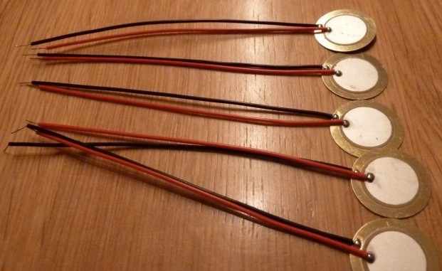

There are other crystals that get lumped together as **piezoelectric materials**. The structure in these crystals aren’t symmetrical but they still exist in an electrically neutral balance. However, if you apply mechanical pressure to a piezoelectric crystal, the structure deforms, atoms get pushed around, and suddenly you have a crystal that can conduct an electrical current. If you take the same piezoelectric crystal and apply an electric current to it, the crystal will expand and contract, converting electrical energy into mechanical energy.

**2.2 Piezoelectric effect**

Piezoelectric Effect is the ability of certain materials to generate an electric charge in response to applied mechanical stress. The word Piezoelectric is derived from the Greek piezein, which means to squeeze or press, and piezo, which is Greek for “push”.

One of the unique characteristics of the piezoelectric effect is that it is reversible, meaning that materials exhibiting the direct piezoelectric effect (the generation of electricity when stress is applied) also exhibit the converse piezoelectric effect (the generation of stress when an electric field is applied).

When piezoelectric material is placed under mechanical stress, a shifting of the positive and negative charge centres in the material takes place, which then results in an external electrical field. When reversed, an outer electrical field either stretches or compresses the piezoelectric material.

## **2.3 How Piezoelectricity Works**

We have specific materials that are suited for piezoelectricity applications, but how exactly does the process work? With the Piezoelectric Effect. The most unique trait of this effect is that it works two ways. You can apply mechanical energy or electrical energy to the same piezoelectric material and get an opposite result.

Applying mechanical energy to a crystal is called a **direct piezoelectric effect** and works like this:

1. A piezoelectric crystal is placed between two metal plates. At this point the material is in perfect balance and does not conduct an electric current.
2. Mechanical pressure is then applied to the material by the metal plates, which forces the electric charges within the crystal out of balance. Excess negative and positive charges appear on opposite sides of the crystal face.
3. The metal plate collects these charges, which can be used to produce a voltage and send an electrical current through a circuit.

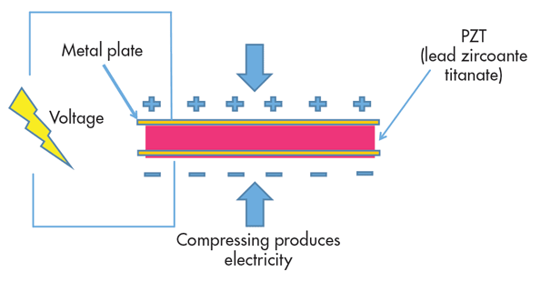

That’s it, a simple application of mechanical pressure, the squeezing of a crystal and suddenly you have an electric current. You can also do the opposite, applying an electrical signal to a material as an **inverse piezoelectric effect.**It works like this:

1. In the same situation as the example above, we have a piezoelectric crystal placed between two metal plates. The crystal’s structure is in perfect balance.
2. Electrical energy is then applied to the crystal, which shrinks and expands the crystal’s structure.
3. As the crystal’s structure expands and contracts, it converts the received electrical energy and releases mechanical energy in the form of a sound wave.

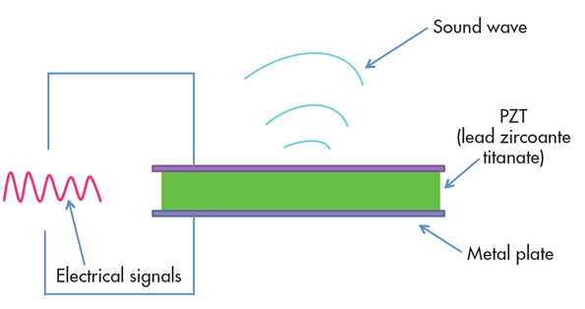

The inverse piezoelectric effect is used in a variety of applications. Take a speaker for example, which applies a voltage to a piezoelectric ceramic, causing the material to vibrate the air as sound waves.

**CHAPTER 3**

**BRIDGE RECTIFIER**

**3.1 INTRODUCTION**

A Bridge rectifier is an Alternating Current (AC) to Direct Current (DC) converter that rectifies mains AC input to DC output. Bridge Rectifiers are widely used in power supplies that provide necessary DC voltage for the electronic components or devices. They can be constructed with four or more diodes or any other controlled solid-state switches.

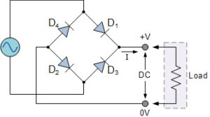  
 Depending on the load current requirements, a proper bridge rectifier is selected. Components’ ratings and specifications, breakdown voltage, temperature ranges, transient current rating, forward current rating, mounting requirements and other considerations are taken into account while selecting a rectifier power supply for an appropriate electronic circuit’s application.

**3.2 WORKING**

During the Positive half cycle of the input AC waveform diodes D1 and D2 are forward biased and D3 and D4 are reverse biased. When the voltage, more than the threshold level of the diodes D1 and D2, starts conducting – the load current starts flowing through it, as shown as red lines path in the diagram below.

During the negative half cycle of the input AC waveform, the diodes D3 and D4 are forward biased, and D1 and D2 are reverse biased. Load current starts flowing through the D3 and D4 diodes when these diodes start conducting as shown in the figure.

[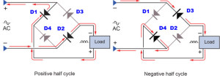](https://www.elprocus.com/wp-content/uploads/2014/06/66.jpg)

We can observe that in both the cases, the load current direction is same, i.e., up to down as shown in the figure – so unidirectional, which means DC current. Thus, by the usage of a bridge rectifier, the input AC current is converted into a DC current. The output at the load with this bridge wave rectifier is pulsating in nature, but for producing a pure DC requires additional filter like capacitor. The same operation is applicable for different bridge rectifiers, but in case of controlled rectifiers thyristors triggering is necessary to drive the current to load.

**CHAPTER 4**

**LM7815 VOLTAGE REGULATOR**

**4.1 INTRODUCTION**

The LM7815 monolithic 3-terminal positive voltage regulators employ internal current-limiting, thermal shutdown and safe-area compensation, making them essentially indestructible. If adequate heat sinking is provided, they can deliver over 1.0A output current. They are intended as fixed voltage regulators in a wide range of applications including local (on-card) regulation for elimination of noise and distribution problems associated with single-point regulation. In addition to use as fixed voltage regulators, these devices can be used with external components to obtain adjustable output voltages and currents.

Considerable effort was expended to make the entire series of regulators easy to use and minimize the number of external components. It is not necessary to bypass the output, although this does improve transient response. Input bypassing is needed only if the regulator is located far from the filter capacitor of the power supply.

**4.2 APPLICATIONS**

* Circuits requiring steady 15v supply
* Protection for devices having specific voltage sensitivity
* DIY projects requiring specific voltage from an existing higher/ varying voltage supply

**4.3 FEATURES**

* Fixed 15V voltage regulators
* Thermal overload protection
* Short circuit protection
* Output transition SOA protection
* Heatsink is required

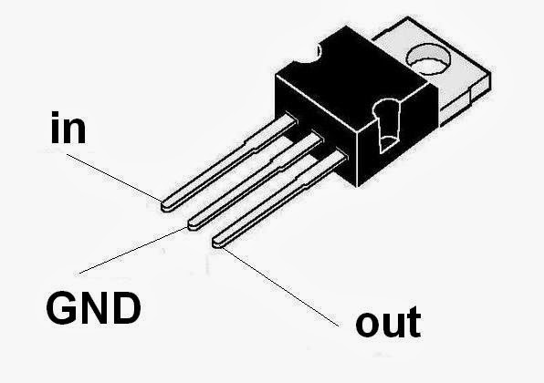

**4.4 SPECIFICATIONS**

* Output Type: Fixed
* Output Voltage: +15V DC
* Current Output: up to 1.5A
* Input Voltage: 17.7 - 35VDC
* Quiescent (standby) current: 8mA
* Dropout Voltage (Max): 2 V @ 1A
* Category: Linear Voltage Regulators - Standard
* Polarity: Positive
* Operating Temperature: 0 to +125°C
* Mounting Style: Through Hole
* Pin Spacing Pitch: 2.54mm
* Hole Diameter: 3.8mm
* Dimensions: 10.4 x 4.6 x 9.15mm

**CHAPTER 5**

**BATTERY**